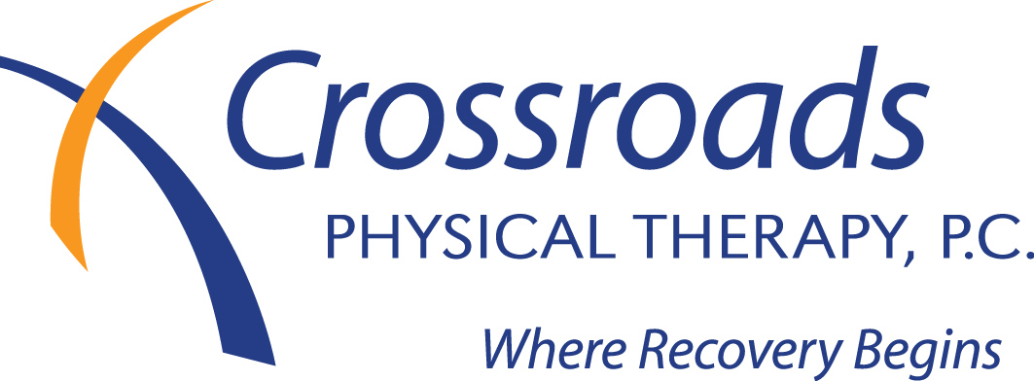
Consent for Treatment

I voluntarily consent to care which may include routine treatment by a physical therapist, his/her designees, as necessary in his/her judgment. I am aware that the practice of physical therapy is not an exact science and I acknowledge that no guarantees have been made to me as the result of service, procedures, treatments or examinations at Crossroads Physical Therapy, P.C.

Use and Disclosure of Protected Health Information
I understand that as part of my health care, Crossroads Physical Therapy originates and maintains paper and/or electronic records describing my health history, symptoms, examination and test results, diagnoses, treatment, and any plans for future care or treatment. I understand that this information serves as:
• A basis for planning my care and treatment,
• A means of communication among the many health professionals who contribute to my care,
• A source of information for applying my diagnosis and surgical information to my bill
• A means by which a third-party payer can verify that services billed were actually provided, and
• A tool for routine healthcare operations such as assessing quality and reviewing the competence of healthcare professionals
I understand that as part of this organization’s treatment, payment, or health care operations, it may become necessary to disclose my protected health information to another entity, and I consent to such disclosure for these permitted uses, including disclosures via fax.

I understand and have been provided with a Notice of Information Practices that provides a more complete description of information uses and disclosures. I understand that I have the following rights and privileges:
• The right to review the notice prior to signing this consent,
• The right to object to the use of my health information for directory purposes, and
• The right to request restrictions as to how my health information may be used or disclosed to carry out treatment, payment, or health care operations

My protected health information may be shared with my family, close friends, or others involved in my care.
Please list: Name and Relationship: ___________________________________ Phone: ___________________
Name and Relationship: ___________________________________ Phone: ___________________

Payment
I request that payment of authorized Medicare/insurance benefits be made either to me, or on my behalf to Crossroads Physical Therapy, P.C. for any services furnished by this provider employed by the same. I authorize any holder of medical information about me to release to my Medicare/insurance carrier, and its agents, any information needed to determine these benefits or the benefits payable for related services. I understand that as a service, Crossroads Physical Therapy will submit all claims to Medicare/my insurance company and that on occasion these institutions will decide not to pay unless I receive services. Therefore, I may be billed for items or services and may have to pay the bill while Medicare/my insurance company denies payment. I agree to be personally and fully responsible for payment. That is, I personally will pay, either out of pocket or through any other insurance that I have. I understand I can appeal Medicare’s decision. Payment can be made at any time to our office. You may pay your co-pay at the time of service. If your insurance requires a primary care referral, it is your responsibility to obtain this. If you do not obtain a referral and your insurance company requires this you will be responsible for payment.

Cancellation and No Show Policy
I understand that by signing the consent for treatment, I have received, read and understand Crossroads Physical Therapy’s cancellation and no show policy.

Signature_______________________________________________ Date __________________
If you are 18 years of age or younger, a parent or guardian must sign this form on your behalf.

Thank you for assisting us with your care.

